Northern University of Business and Technology Khulna
Department of Computer Science and Engineering
WEEK 12: FINAL PROJECT REPORT
Project Title: AI-Powered Resume Analyzer and Career Copilot (RESUMIND)
Course Title: Mobile Computing Lab
Course Code: CSE4204
Submitted to:
Md. Riaz Mahmud
Assistant Professor
Department of Computer Science and Engineering
Northern University of Business and Technology, Khulna
Submission Date: 22 October 2026

TEAM INFORMATION SHEET
Field | Details
Official Team Name | CSE4204-8A-T05
Section | 8A
Project Title | AI-Powered Resume Analyzer and Career Copilot (RESUMIND)
Team Member List with IDs | 1. Mahammad Hasan (ID: 11220320828) - Team Leader / Frontend Developer + UI/UX Designer  2. Shanawaz Sakib (ID: 11220320916) - Core System Integration Engineer  3. Ashikur Rahman Himel (ID: 11220320833) - Database Storage & Quality Controller  4. Rasel Ratul (ID: 11220320827) - Backend Developer
Live Application Link | https://ai-resume-analyzer-psi-lime.vercel.app
GitHub Repository Link | https://github.com/mahamud894/AI_Resume_Analyzer
Figma Link | https://www.figma.com/design/Ls0B3DIjxRKrP2RIzYQxPG/AI-Resume-Analyzer?node-id=2-2&t=lFEVQCoUHt0JSumI-1

Abstract
Many capable students and fresh graduates are rejected before a human ever reads their resume, because an Applicant Tracking System (ATS) filters it out for weak keywords, unclear structure or poor formatting. RESUMIND is a responsive web application that lets a job seeker upload a PDF resume, paste a job description and receive an AI-generated evaluation within about 20 seconds: an overall score, five category scores (ATS, tone & style, content, structure, skills) and concrete tips.
Beyond analysis, RESUMIND rewrites the resume into the European (Europass) CV standard without inventing any facts, measures the improvement with a before / after score, and generates a matching one-page cover letter. The system is built with React 19 and React Router 8 on the frontend, an Express 5 REST API on the backend, MongoDB Atlas (with GridFS for files) as the database, and Google Gemini in structured-JSON mode as the AI engine. It is deployed on Vercel (frontend) and Render (backend), protected by bcrypt + JWT authentication and optional Google Sign-In, and verified by 48 automated API tests that run in GitHub Actions on every push.
Live application | https://ai-resume-analyzer-psi-lime.vercel.app
Backend API | https://resumind-api-3kpd.onrender.com/api/health
Source code | https://github.com/mahamud894/AI_Resume_Analyzer

1. Introduction
Recruitment today is largely automated. Large employers and many local companies receive hundreds of applications for one position and use ATS software to rank them before a recruiter looks at the list. A resume that is well-written for a human can still score poorly in such a system if it lacks the job's keywords, uses an unusual layout or hides important information.
RESUMIND ("AI-Powered Resume Analyzer and Career Copilot") was developed by team CSE4204-8A-T05 as the term project of the Mobile Computing Lab. It acts as a personal career assistant that works on any device: the user signs in, uploads a resume, describes the job, and receives structured, explainable feedback. The application then helps the user act on that feedback by producing an improved Europass CV and a cover letter that are both tied to the same job.

1.1 Scope
- Secure account management (email/password and Google Sign-In, change password, delete account).
- PDF resume upload with a page-1 preview, stored in MongoDB GridFS.
- AI analysis of a resume against a specific job title and description.
- AI rewrite into a Europass CV with an editable, printable A4 layout and a list of every change.
- Before / after score comparison and a score-history chart.
- AI cover letter generation (formal or modern tone) with inline editing and PDF download.
- A history dashboard of all resumes and analyses, and a printable report.
- Responsive design for mobile, tablet and desktop; deployment to the public internet.

1.2 Document structure
Chapter 2 states the problem and Chapter 3 the objectives. Chapter 4 explains the methodology, Chapter 5 the architecture and Chapter 6 the database design. Chapter 7 describes the AI integration and Chapter 8 security and authentication. Chapter 9 presents the implementation, Chapter 10 testing and Chapter 11 the results. Chapter 12 covers deployment, Chapter 13 limitations and future work, and Chapter 14 concludes. The individual contributions are listed in Chapter 15.

2. Problem Statement

2.1 The existing problem
Modern recruitment relies heavily on Applicant Tracking Systems. Capable candidates — especially fresh graduates in Bangladesh who are applying to international or remote positions — are frequently filtered out automatically because of poor formatting, weak action verbs or missing keywords from the job description. They receive repeated rejections without knowing what to fix.

2.2 Why the problem matters
- Job hunting is highly competitive; a single missed keyword can remove an otherwise qualified applicant.
- Writing a personalised cover letter for every application is time-consuming, so many applicants send generic letters.
- European and international employers expect the Europass CV format (MM/YYYY dates, CEFR language levels, EQF qualification levels), which most local graduates have never been taught.

2.3 Why existing solutions are insufficient
Table 1: Comparison with existing tools
Tool | What it does well | Gap that RESUMIND addresses
Jobscan | Keyword match rate against a job description | Paid after a few scans; keyword matching without contextual explanation; no Europass rewrite
Resume Worded | Line-by-line resume feedback | Generic scoring not tied to one job; cover letters and full rewrite are premium
Reactive Resume | Free, open-source resume builder | Builder only — no AI analysis, no ATS score, no cover letter tied to the job
Europass online editor | Official EU CV template | Manual data entry; no feedback on content quality or job fit

2.4 Why AI is relevant
A rule-based keyword counter cannot judge whether a bullet point demonstrates a skill or whether the tone is professional. A large language model can read the resume and the job description in context, score each dimension, explain its reasoning in plain language and rewrite content — as long as its output is constrained so that it stays structured, consistent and truthful. RESUMIND uses Google Gemini with a strict JSON schema and code-level post-checks to achieve exactly that.

3. Objectives
The original proposal (Week 02) defined the objectives below. During development the team replaced the client-only Puter.js approach with its own backend so that the system matches the course ERD and the Week 06 backend requirements; the objectives were updated accordingly.
Table 2: Project objectives and how they were met
# | Objective | How it is achieved | Status
O1 | Secure authentication and session management | bcrypt password hashing, 7-day JWT, Google Sign-In, token invalidation on password change, rate limiting | Done
O2 | Document vault with history | PDF + preview image in MongoDB GridFS; dashboard lists every resume with its analyses | Done
O3 | AI-driven ATS analysis against a job | Gemini JSON mode with a fixed schema: overall score + 5 categories with tips | Done
O4 | Actionable improvement | Europass CV rewrite that addresses every "improve" tip, never invents facts, lists each change | Done
O5 | Measure the improvement | Re-score the improved CV for the same job; before/after comparison and history chart | Done
O6 | Personalised cover letter | European one-page business letter generated only from CV facts; editable and printable | Done
O7 | Responsive, mobile-friendly UI | Tailwind CSS 4 mobile-first layout; tested at phone, tablet and desktop widths | Done
O8 | Quality and deployment | 48 automated API tests in CI; live on Vercel + Render + Atlas | Done

4. Methodology

4.1 Development process
The team followed an iterative, incremental process aligned with the weekly lab schedule. Each week produced a working increment that was reviewed by the course teacher, and feedback was folded into the next iteration. GitHub was used for version control, with every change pushed to the main branch and verified by continuous integration.
Table 3: Weekly development timeline
Week | Phase | Main outcome
02 | Proposal | Problem, objectives, feasibility, similar systems, team roles
03 | Requirements (SRS) | Functional / non-functional requirements, use-case diagram, first ERD
04 | System design | Architecture, activity diagram, refined ERD
05 | UI / UX | Wireframes and design planning (RESUMIND visual identity)
06 | Backend & database | Express API, MongoDB models, JWT authentication
07 | Frontend integration | React pages connected to the REST API
08 | AI integration | Gemini analysis with structured JSON output
09 | Feature completion | Europass CV, cover letter, account management
10 | Testing | Vitest + Supertest suite, testing report
11 | Deployment | Vercel + Render + MongoDB Atlas, CI on GitHub Actions
12–14 | Documentation & presentation | This report, user manual, API documentation, slides, viva

4.2 From Puter.js to an own backend
The first prototype (Week 07) followed a tutorial and ran entirely in the browser using the Puter.js SDK for login, file storage, key-value data and AI. This was quick to build but did not satisfy the course requirements for a backend, a database that matches the ERD, or control over security and validation. The team therefore built its own Express + MongoDB backend and moved the AI calls to the server, where the API key is hidden and the output can be validated.
Table 4: Migration from the prototype to the final system
Concern | Prototype (Puter.js) | Final system
Login | puter.auth.signIn() | POST /api/auth/login, /register, /google (bcrypt + JWT)
File storage | puter.fs | MongoDB GridFS (uploads.files / uploads.chunks)
Data | puter.kv key-value store | MongoDB collections that match the ERD
AI | puter.ai in the browser | Gemini on the server, JSON schema, retries, post-checks
Security | Handled by Puter | helmet, CORS allow-list, input validation, rate limits

4.3 Tools and technologies
Table 5: Technology stack
Layer | Technology | Why it was chosen
Frontend | React 19, React Router 8, TypeScript, Tailwind CSS 4, Zustand, pdf.js | Component model, type safety, fast mobile-first styling, light global state, page-1 PDF preview in the browser
Backend | Node.js, Express 5, Multer, pdf-parse, express-validator, helmet | Same language as the frontend, minimal and well-documented, mature security middleware
Database | MongoDB Atlas, Mongoose 9, GridFS | Flexible documents fit nested AI feedback and CVs; free managed cluster; files stored with the data
AI | Google Gemini via @google/genai (JSON mode) | Free tier, long context, structured output with a JSON schema
Auth | bcryptjs, jsonwebtoken, google-auth-library | Industry-standard password hashing, stateless tokens, verified Google ID tokens
Testing / CI | Vitest, Supertest, mongodb-memory-server, GitHub Actions | Real HTTP tests against an in-memory database; runs on every push
Hosting | Vercel (frontend), Render (backend), Docker Compose (local) | Free tiers with automatic deploys from GitHub

5. System Architecture
RESUMIND uses a classic three-tier client–server architecture. The browser runs a single-page React application; it talks only to the Express REST API over HTTPS using JSON and a JWT bearer token. The API is the only component that can reach the database and the Gemini API, so secrets never leave the server.
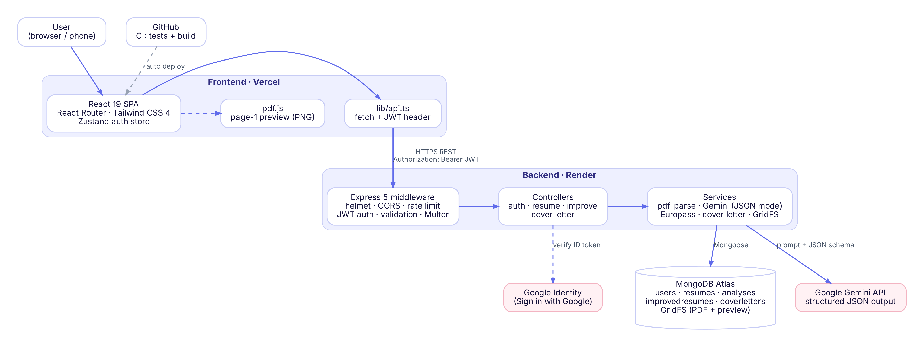
Figure 1: Three-tier deployment architecture

5.1 Components
- Presentation tier (Vercel): React SPA — landing page, auth, dashboard, upload, result, Europass CV, cover letter and account pages. pdf.js renders a preview image of page 1 before upload.
- Application tier (Render): Express 5 API organised as routes → middleware (auth, validation, upload, rate limit) → controllers → services (pdf, Gemini, Europass, cover letter).
- Data tier (MongoDB Atlas): five collections plus GridFS buckets for the uploaded PDFs and preview images.
- External services: Google Gemini (analysis, rewrite, scoring, cover letter) and Google Identity Services (Sign-In).

5.2 Backend structure
backend/
├── server.js entry point: connect to MongoDB, start HTTP server
└── src/
├── app.js helmet, CORS, JSON parser, routes, error handler
├── config/ env.js (validated settings), db.js
├── models/ User, Resume, Analysis, ImprovedResume, CoverLetter
├── routes/ authRoutes.js, resumeRoutes.js
├── middleware/ auth.js (JWT), upload.js (Multer), validate.js, errorHandler.js
├── controllers/ auth, resume, improve, coverLetter
├── services/ pdfService, geminiService, europassService, coverLetterService
└── utils/ ApiError, token

5.3 Request lifecycle (analysis example)
- The user submits the upload form; the frontend sends POST /api/resume/upload (multipart) with the JWT.
- Multer checks the type and size and verifies that the bytes start with %PDF-; the files go to GridFS.
- The frontend sends POST /api/resume/analyze with the resume id and job details.
- requireAuth verifies the token; express-validator checks the input; the AI rate limiter checks the user's hourly quota.
- The controller extracts text with pdf-parse, calls Gemini in JSON mode, normalises the result and saves an Analysis.
- The API returns 201 { analysis }; the frontend navigates to the result page and renders the scores.

6. Database Design
MongoDB was chosen because the main entities contain deeply nested, variable-length data (AI feedback with tip arrays, a full Europass CV, a structured letter). Each entity is still a separate collection with explicit references, so the design maps one-to-one to the ERD defined in Weeks 03–04.
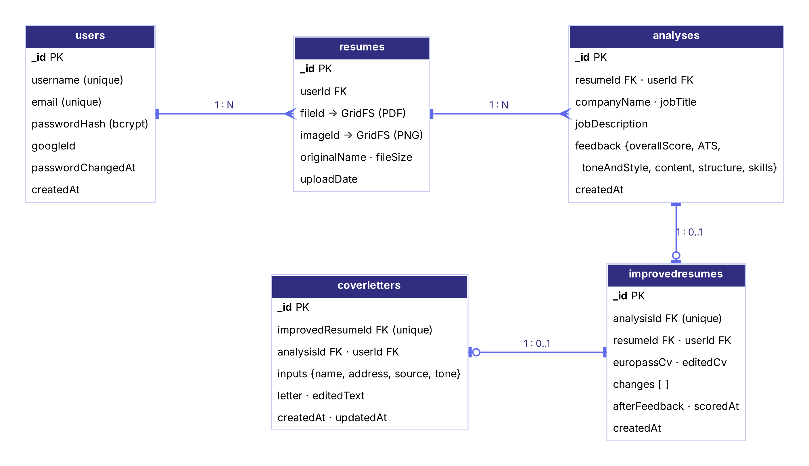
Figure 2: Entity–relationship diagram of the final database
Table 6: Collections
Collection | Key fields | Relationship
users | username (unique), email (unique, lowercase), passwordHash, hasPassword, googleId (unique, sparse), passwordChangedAt, createdAt | 1 user → N resumes
resumes | userId, fileId, imageId (→ GridFS), originalName, fileSize, uploadDate | 1 resume → N analyses
analyses | resumeId, userId, companyName, jobTitle, jobDescription, feedback { overallScore, ATS, toneAndStyle, content, structure, skills }, createdAt | 1 analysis → 0..1 improved resume
improvedresumes | analysisId (unique), resumeId, userId, europassCv, editedCv, editedAt, changes[], afterFeedback, scoredAt | 1 improved resume → 0..1 cover letter
coverletters | improvedResumeId (unique), analysisId (unique), userId, inputs, letter, editedText, timestamps | —
uploads.files / .chunks | GridFS: the PDF and PNG bytes in 255 KB chunks | referenced by resumes

6.1 Design decisions
- Ownership on every document: userId is stored on analyses, improved resumes and cover letters, so every query is filtered by the logged-in user and one user can never read another user's data.
- Unique indexes enforce cardinality: one improved resume per analysis and one cover letter per improved resume; regenerating replaces the previous version.
- Cascade delete: deleting a resume removes its analyses, improved resumes, cover letters and both GridFS files; deleting the account removes everything owned by the user.
- AI output kept separate from user edits: europassCv (AI) and editedCv (user) are stored side by side, so the user can always reset to the AI version.
- Files in GridFS, not on disk: Render's disk is temporary, so storing files in Atlas keeps them safe across redeploys.

7. AI Integration
All four AI features share one service (geminiService.callGeminiJson) that sends a prompt to Gemini with responseMimeType: "application/json" and a responseJsonSchema. The model is therefore forced to return valid JSON in a known shape; the backend still validates and normalises every field before saving.
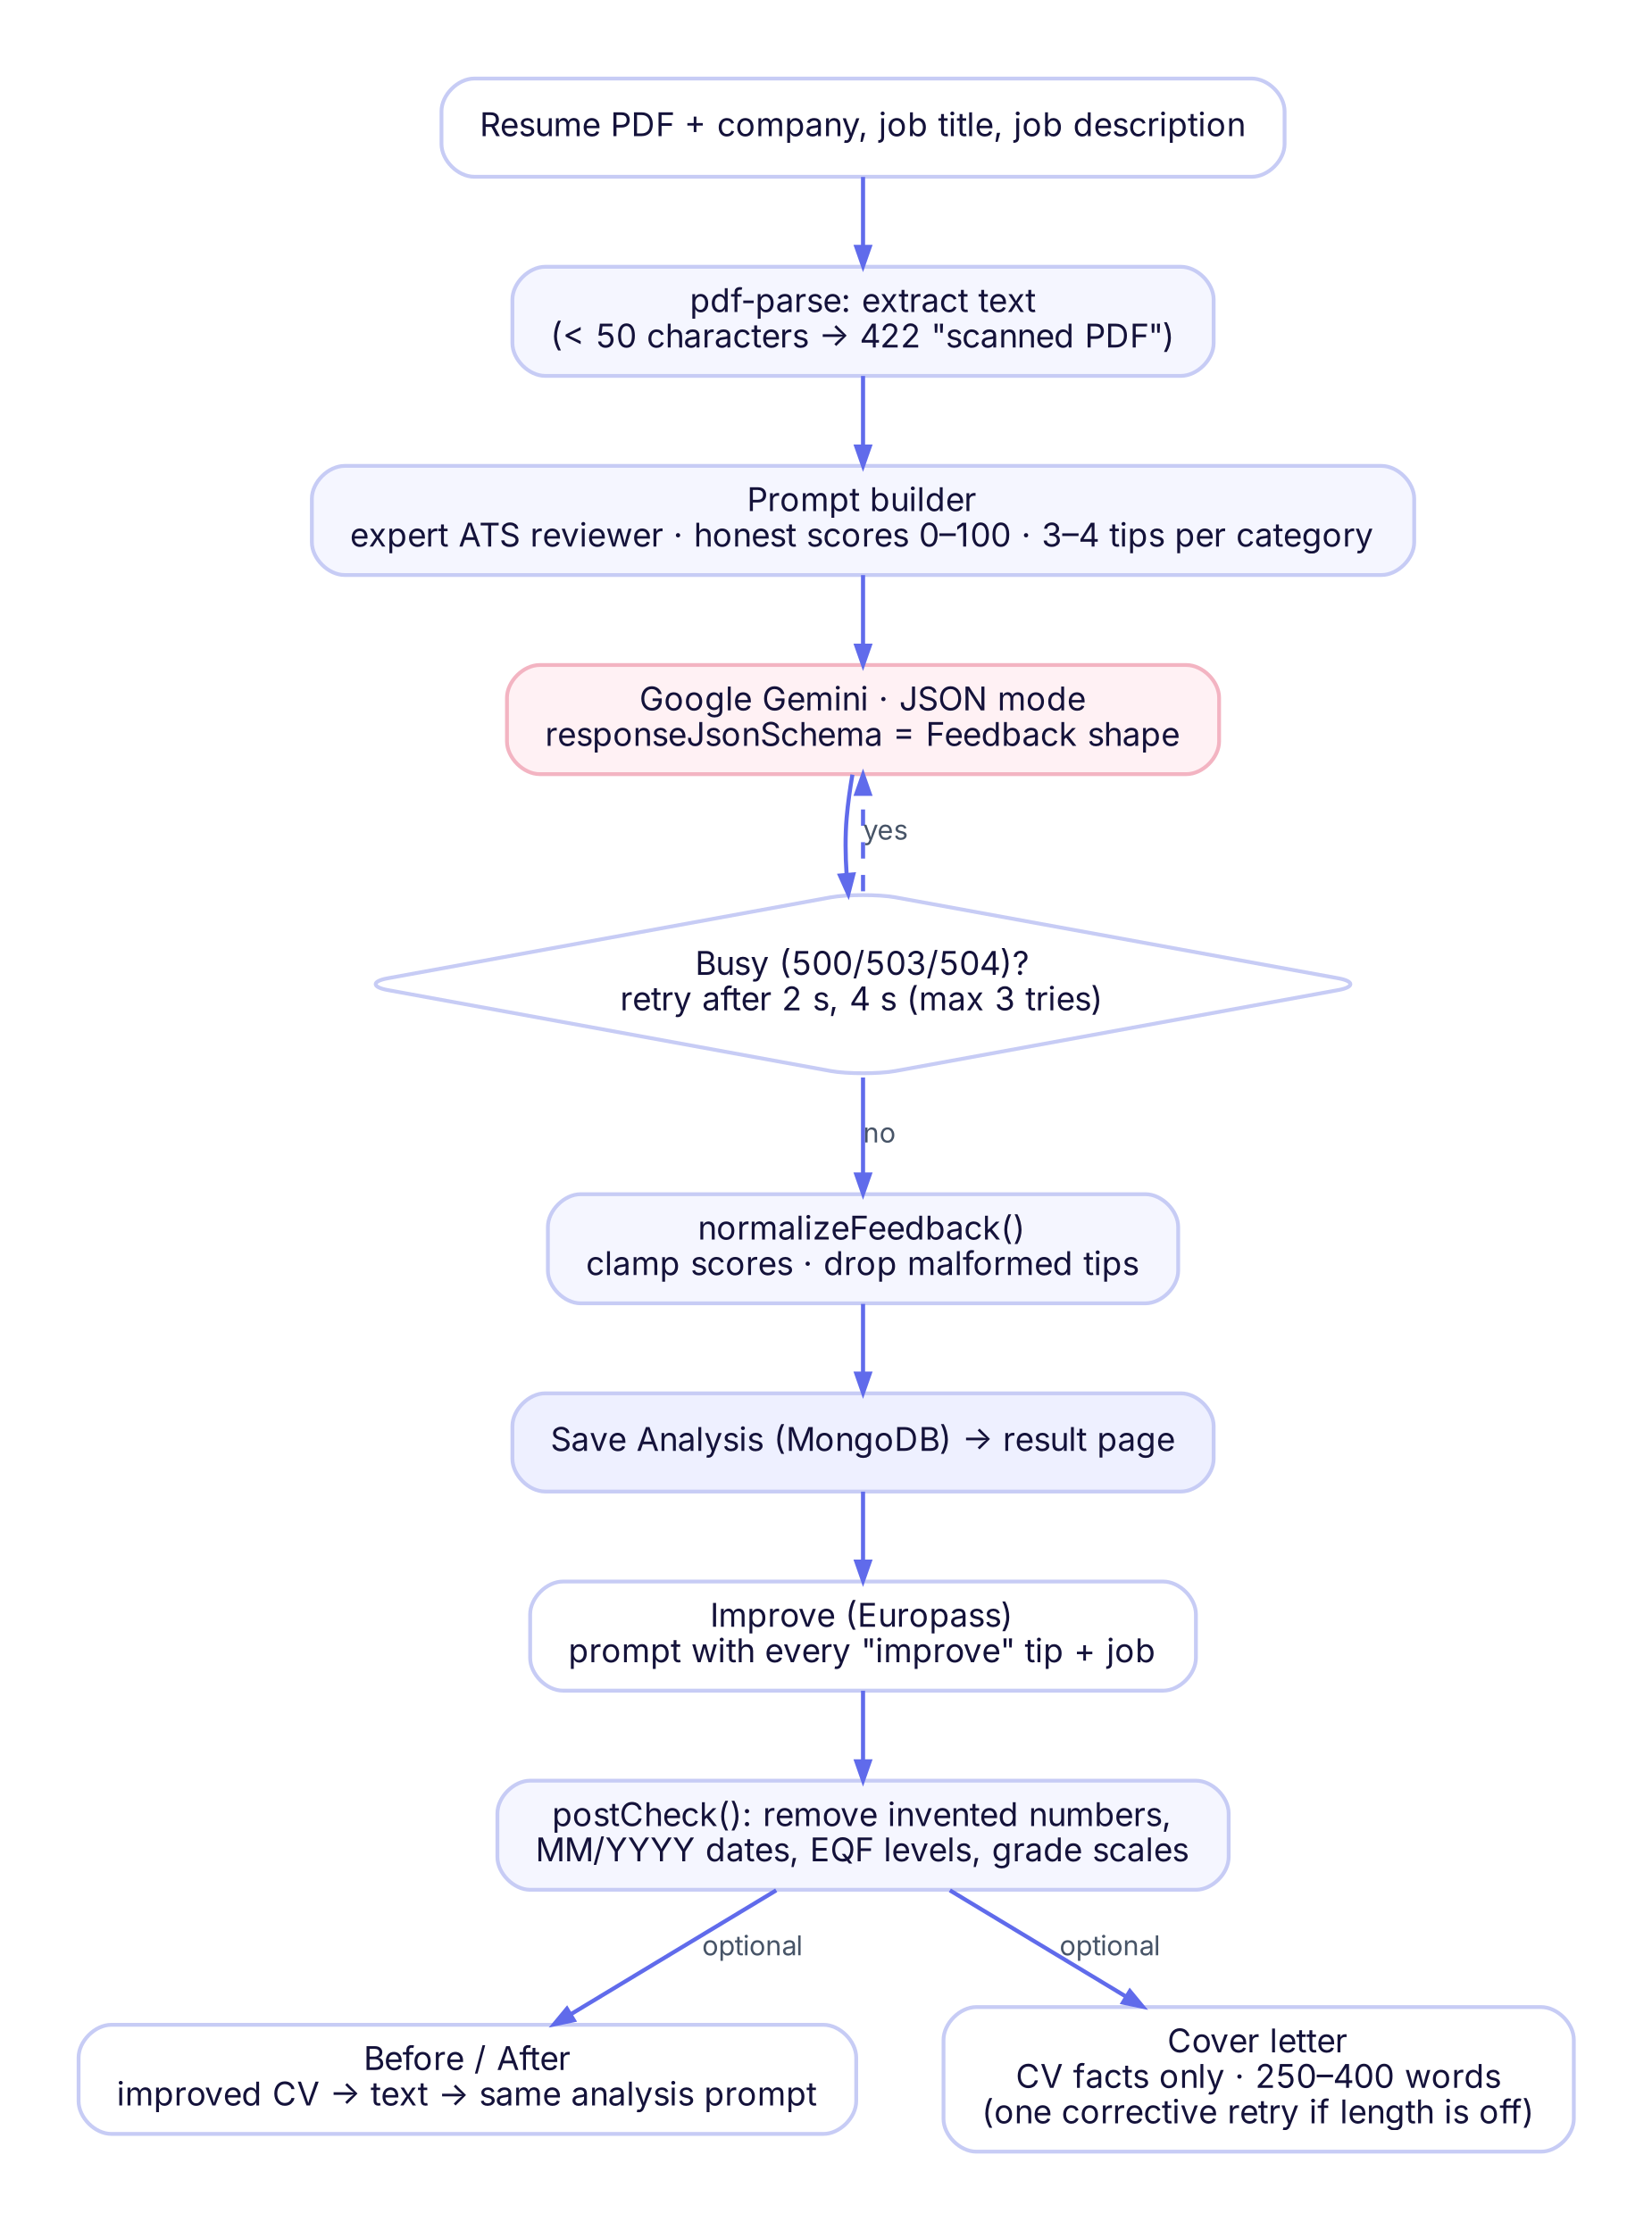
Figure 3: AI workflow from PDF upload to cover letter

7.1 Resume analysis
The resume text (up to 30 000 characters) is extracted with pdf-parse and sent together with the company, job title and job description. The schema requires an overallScore (0–100) and five categories, each with a score and a list of tips of type good or improve with an explanation. Scores are clamped to 0–100 and malformed tips are dropped.
{ "overallScore": 72,
"ATS": { "score": 78, "tips": [ { "type": "good", "tip": "Clear section headings" } ] },
"toneAndStyle": { "score": 75, "tips": [ { "type": "improve", "tip": "Avoid first person", "explanation": "..." } ] },
"content": { ... }, "structure": { ... }, "skills": { ... } }

7.2 Europass CV improvement
The improvement step sends the resume text, every "improve" tip and the job details. The prompt sets strict rules: never invent experience, degrees, companies, dates, numbers or skills; keep job titles exactly; rephrase with strong action verbs; add job keywords only where the candidate really has the skill; use clear placeholders such as [Add your English CEFR level, e.g. B2] where Europass needs missing information; and list every change with its reason.
Because a language model can still ignore instructions, a deterministic post-check in code enforces the most important rules after Gemini answers:
Table 7: Post-check rules applied in code
Rule | Example
Numbers not present in the original resume become placeholders | "by 40%" → "by [Add a measurable result, e.g. X%]"
All dates in MM/YYYY format | "November 30, 2024" → "11/2024"
Ongoing degree shown as expected graduation | "Current" → "Expected 08/2026"
Qualification names written in full with EQF level | "H.S.C" → "Higher Secondary Certificate (HSC)", EQF 4
Grade with its scale | "4.67" → "GPA 4.67 / 5.00"
Personal data not used in Europass removed | religion, marital status, parents' names, date of birth

7.3 Before / after score
The improved CV (the user's edited version if one exists) is converted back to text, placeholders are removed so that only real content counts, and it is scored with the same prompt and the same job as the original analysis. The result is stored as afterFeedback; the result page shows the change per category and a score-history chart.

7.4 Cover letter
Gemini writes only the creative parts of the letter — the opening, two body paragraphs, the closing and a list of highlights that map job requirements to CV evidence. The backend fills in the fixed parts (sender, date, recipient, subject, salutation and sign-off) so that the format is always correct. If the body is outside 250–400 words, Gemini is asked once more to fix the length.

7.5 Reliability and cost control
- Retries: temporary Gemini errors (500/503/504) are retried up to three times with 2 s and 4 s pauses.
- Clear errors: 422 for scanned PDFs without text, 429 for rate limits, 502 for model failure, 503 when the key is missing or the model is still busy.
- Quota: each user may make 15 AI requests per hour; failed requests do not count.
- Key safety: the Gemini API key exists only in the server environment and is never sent to the browser.

8. Security and Authentication
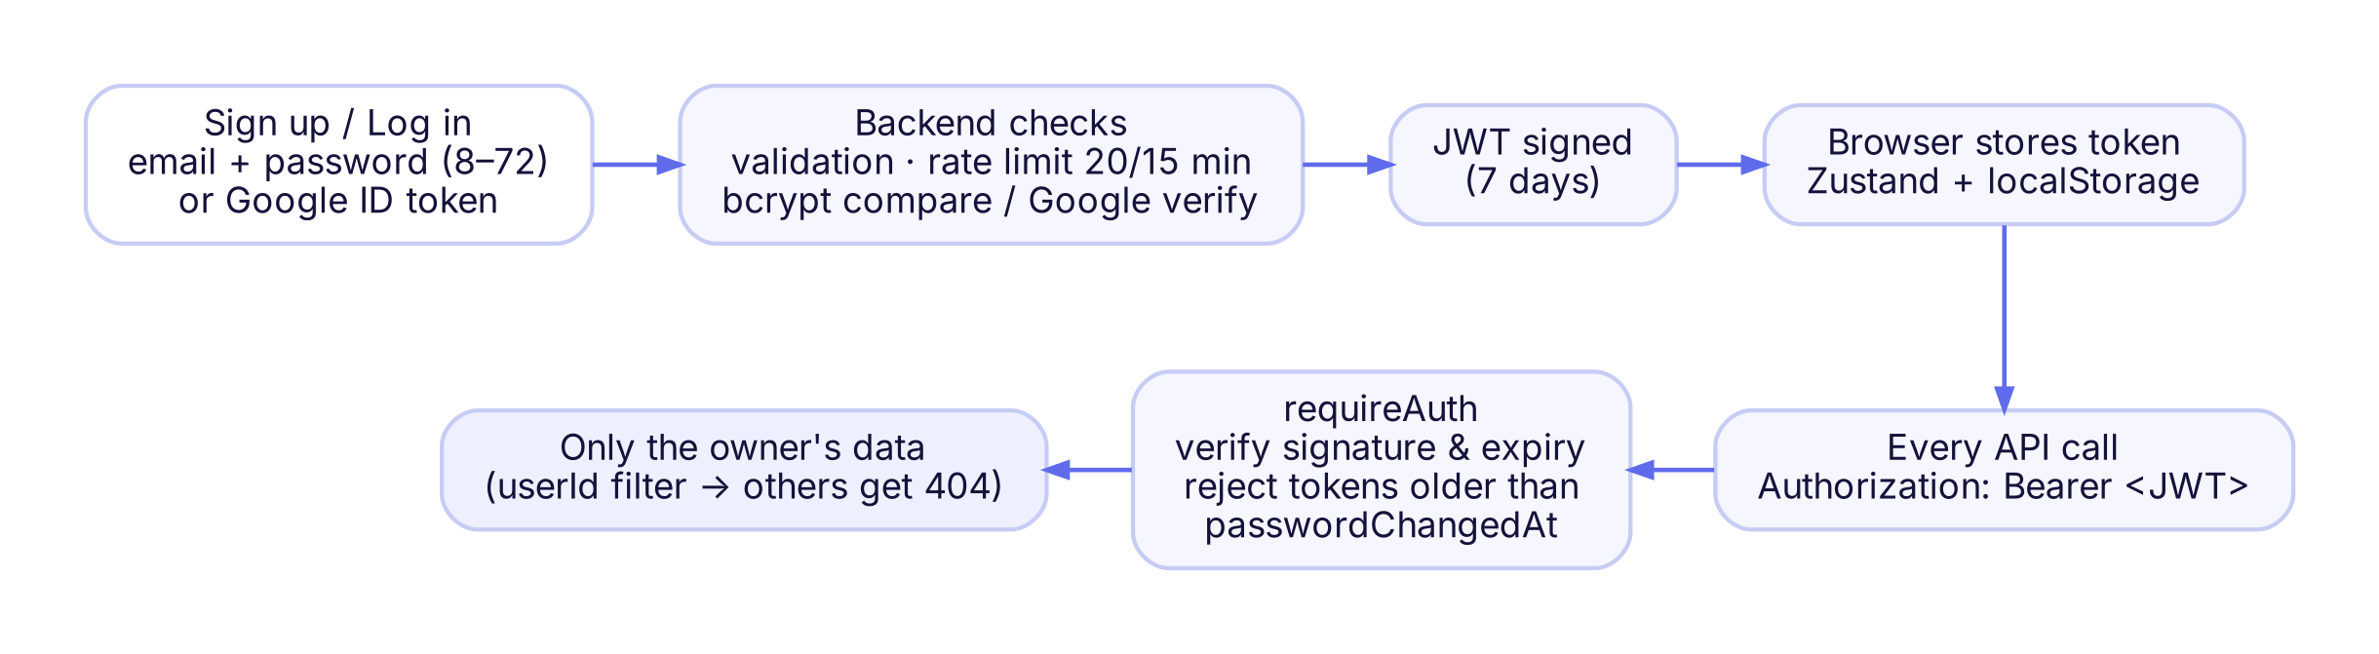
Figure 4: Authentication flow (email/password and Google Sign-In)
- Passwords are 8–72 characters and hashed with bcrypt; the plain password is never stored or logged.
- JWT tokens are signed with a long random secret and expire after 7 days. When the password changes, passwordChangedAt is updated and every older token is rejected, which logs out other devices.
- Google Sign-In sends a Google ID token to the backend, which verifies it with google-auth-library against the project's client id and only accepts verified e-mail addresses.
- Rate limits: 20 auth requests per 15 minutes per IP (register, login, Google, change password, delete account) and 15 AI requests per hour per user.
- Input validation: every body and URL parameter is checked with express-validator; ids must be valid ObjectIds and belong to the user.
- Uploads: PDF only, max 10 MB, magic-byte check (%PDF-), random file names, stored in GridFS.
- HTTP hardening: helmet security headers, CORS restricted to the frontend origin, 1 MB JSON limit, central error handler that never leaks stack traces in production.
- Secrets: stored in .env locally and in the Vercel/Render dashboards in production; .env is git-ignored.

9. Implementation
The frontend has nine routes. Logged-out visitors see the landing page; after login they go straight to the dashboard. Every logged-in page shares the same top bar, page title and card style, and a progress stepper (Upload → Analysis → Europass CV → Cover letter) shows where the user is.
Table 8: Frontend routes
Route | Page | Purpose
/ | Landing | Product introduction, how it works, features, team
/auth | Login / Sign up | Email + password or Google Sign-In
/dashboard | Dashboard | History of resumes and analyses, score badges
/upload | Upload | PDF drop zone, job fields, processing animation
/resume/:id | Result | Scores, tips, before/after, history chart, report PDF
/resume/:id/improved/:analysisId | Europass CV | Improved CV, inline editing, change list, PDF
.../cover-letter | Cover letter | Generate, edit and download the letter
/account | Account | Change password, delete account
/wipe | Wipe | Delete all of the user's data

9.1 Landing and authentication
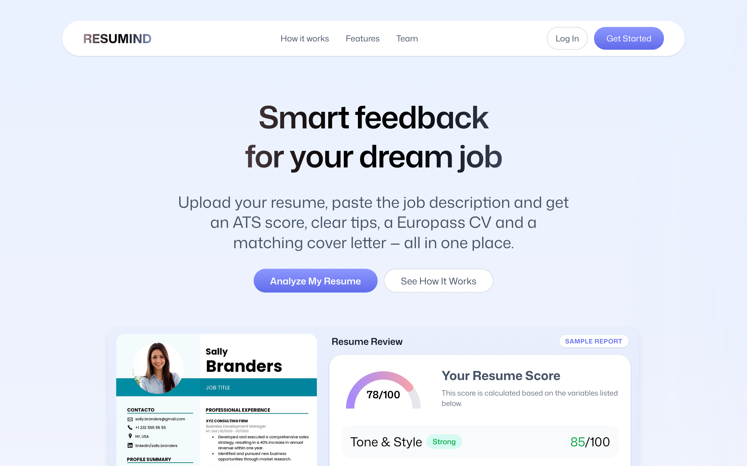
Figure 5: Landing page
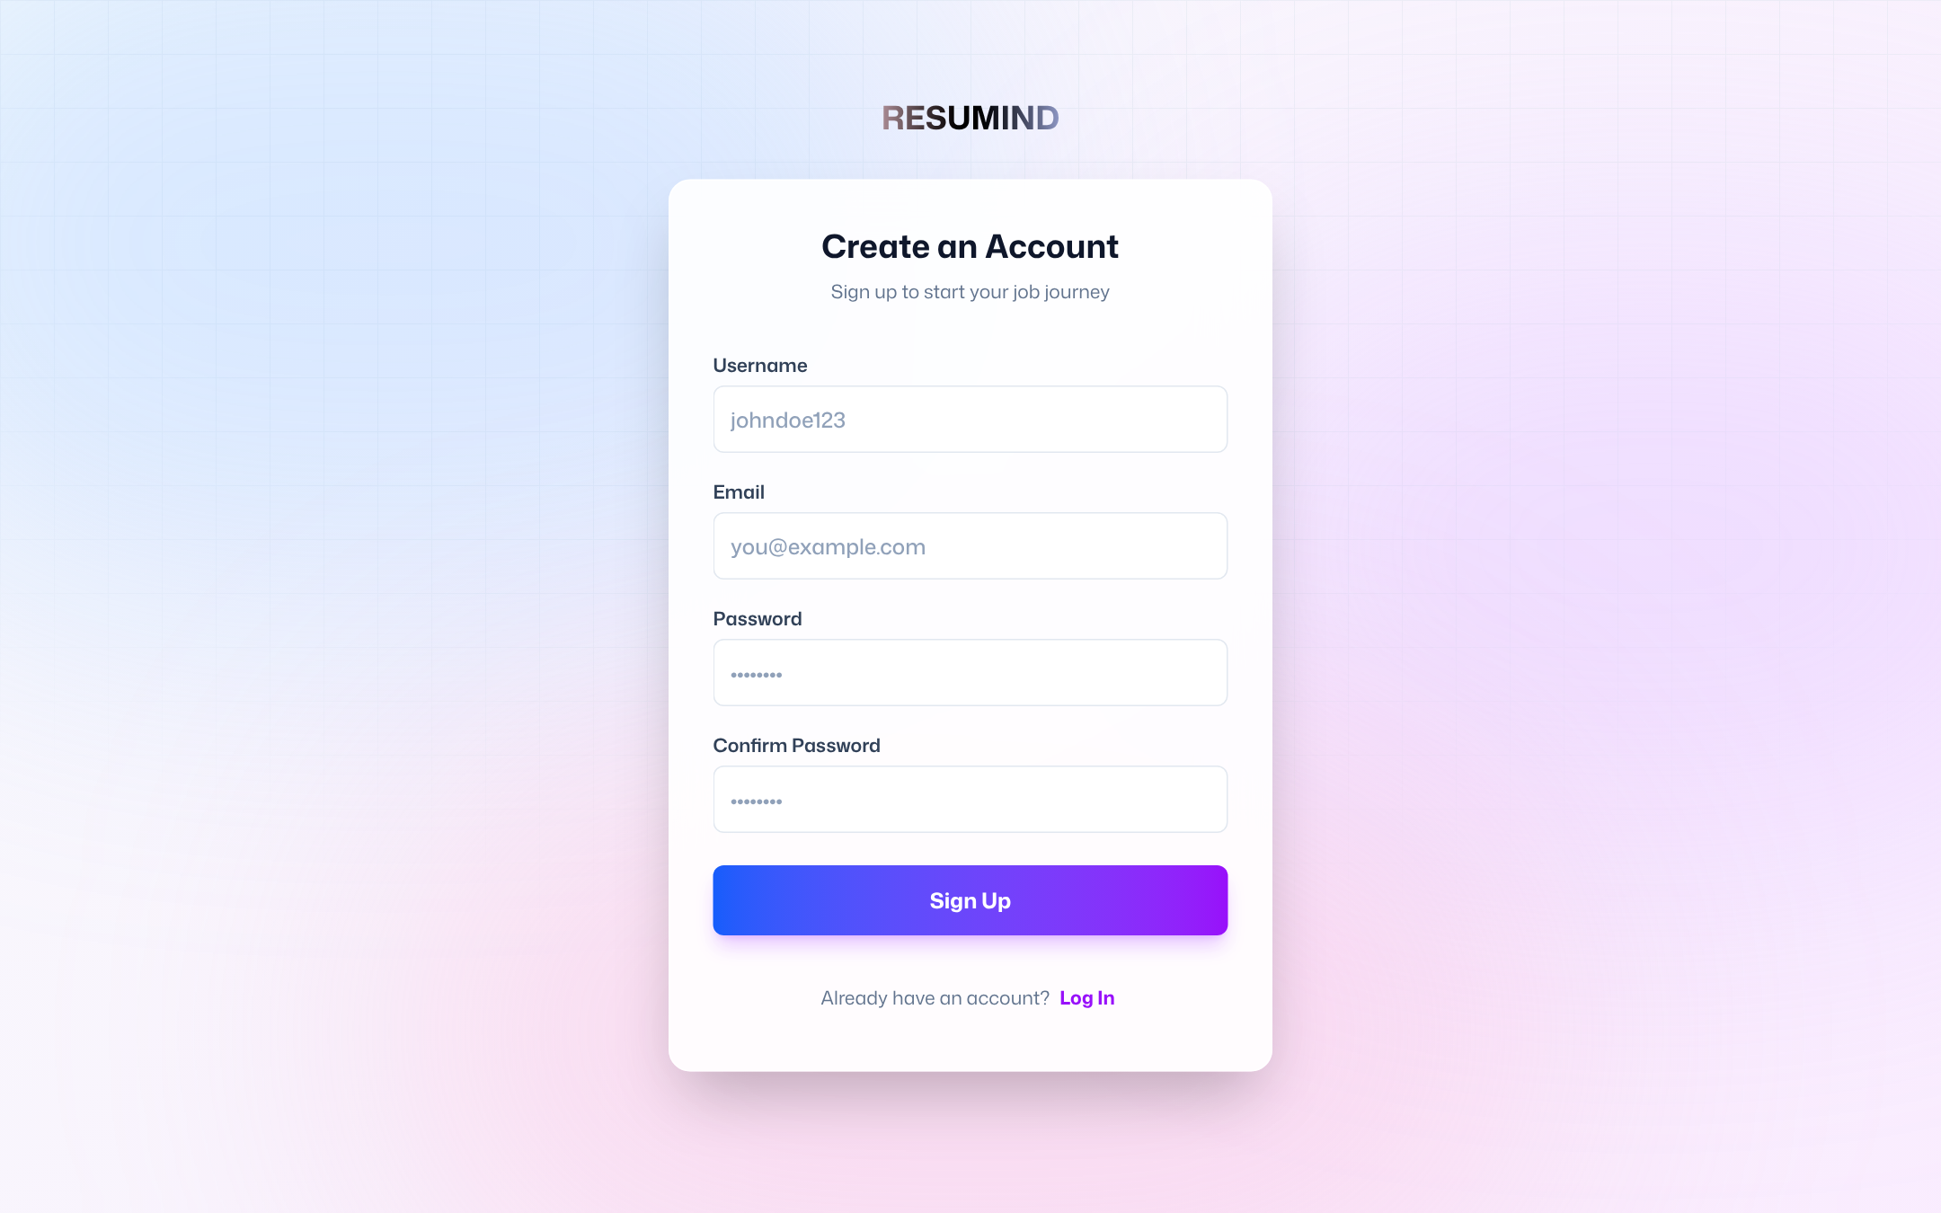
Figure 6: Sign-up dialog with Google Sign-In

9.2 Dashboard and upload
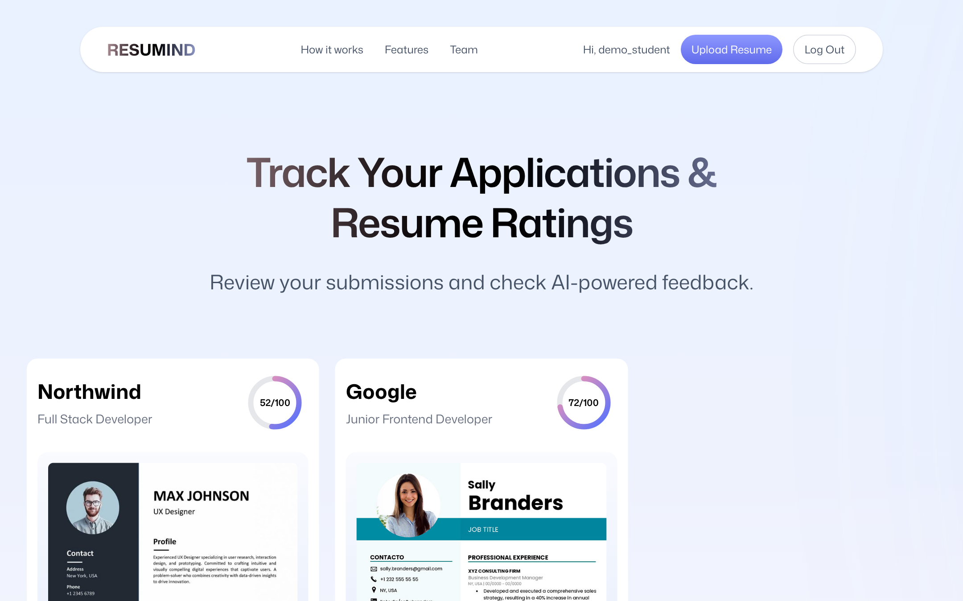
Figure 7: Dashboard with resume history
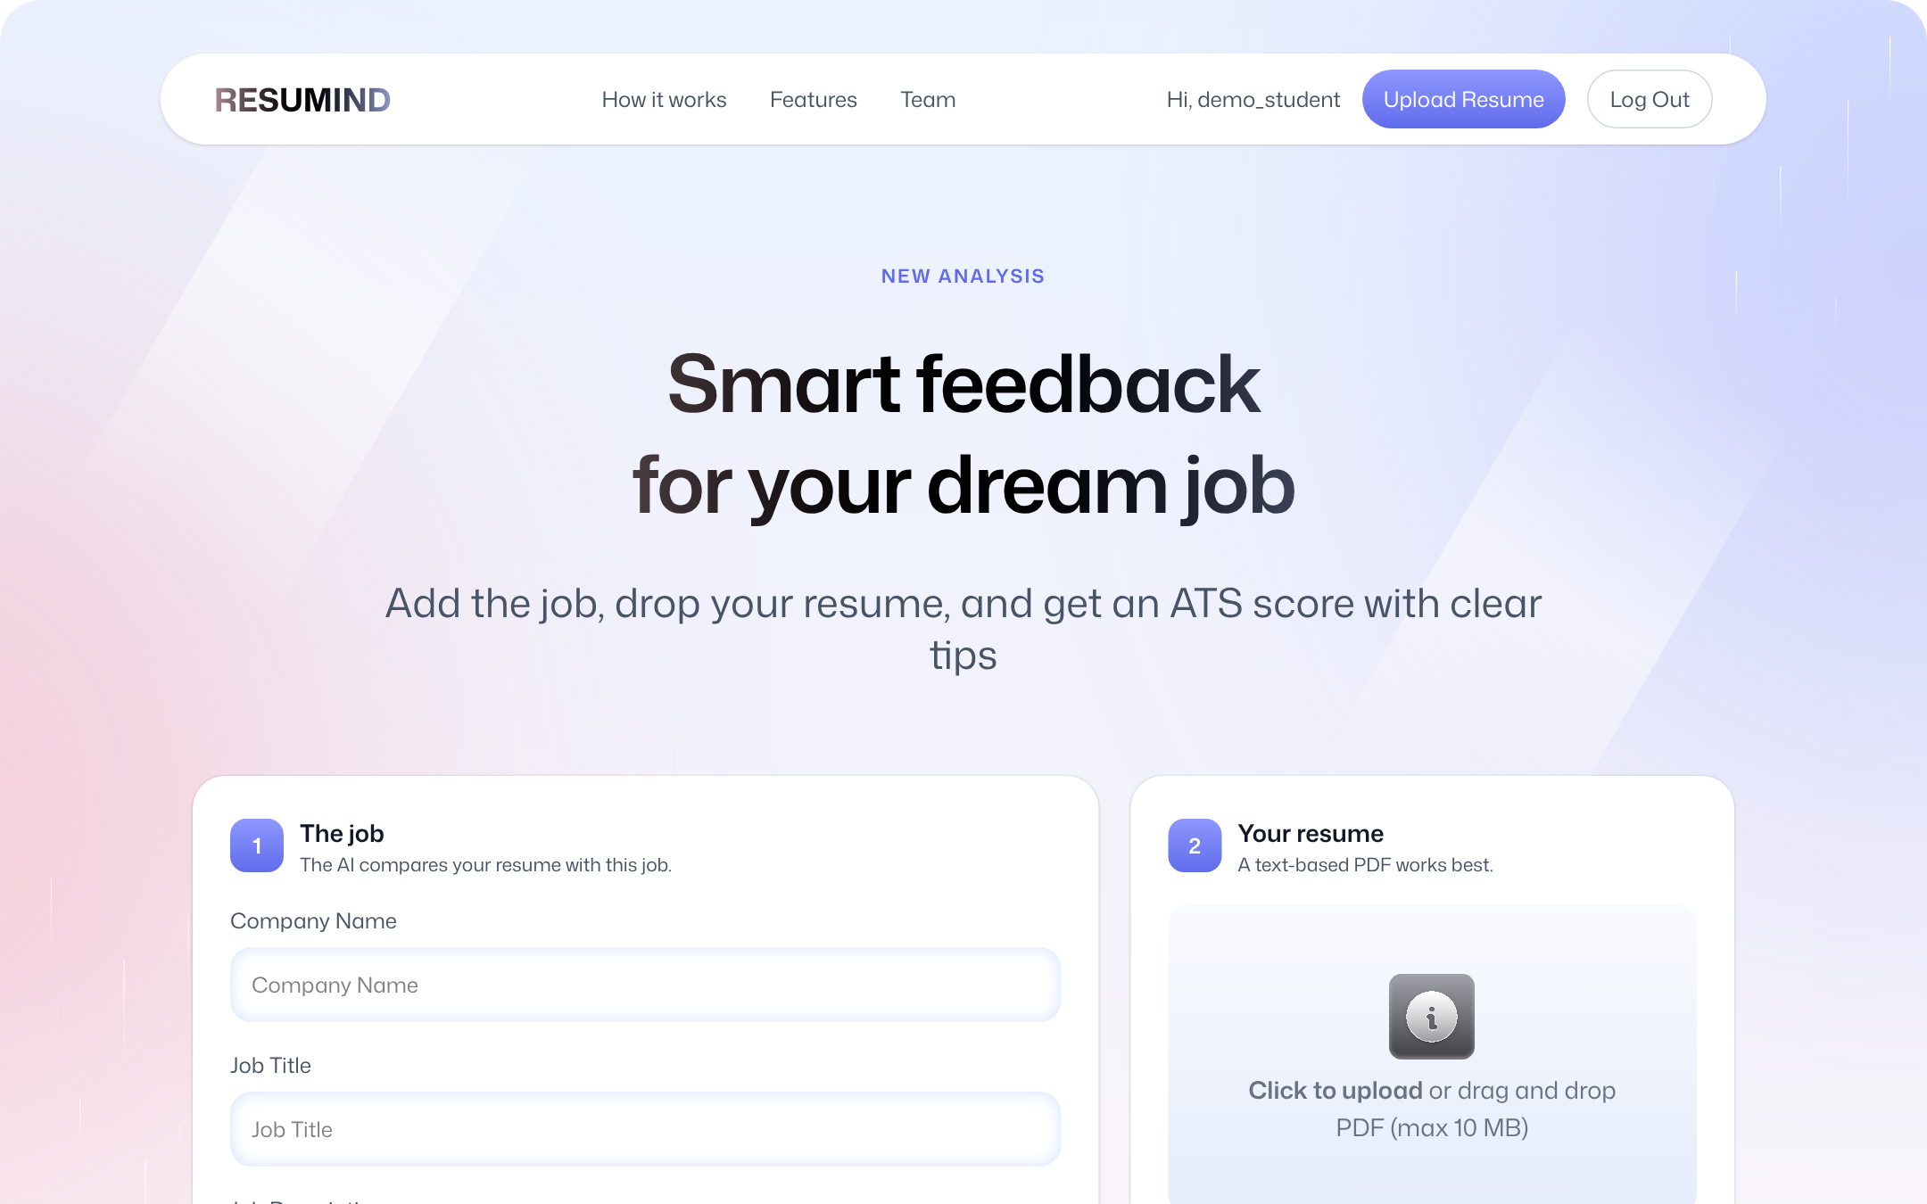
Figure 8: Upload page with job details
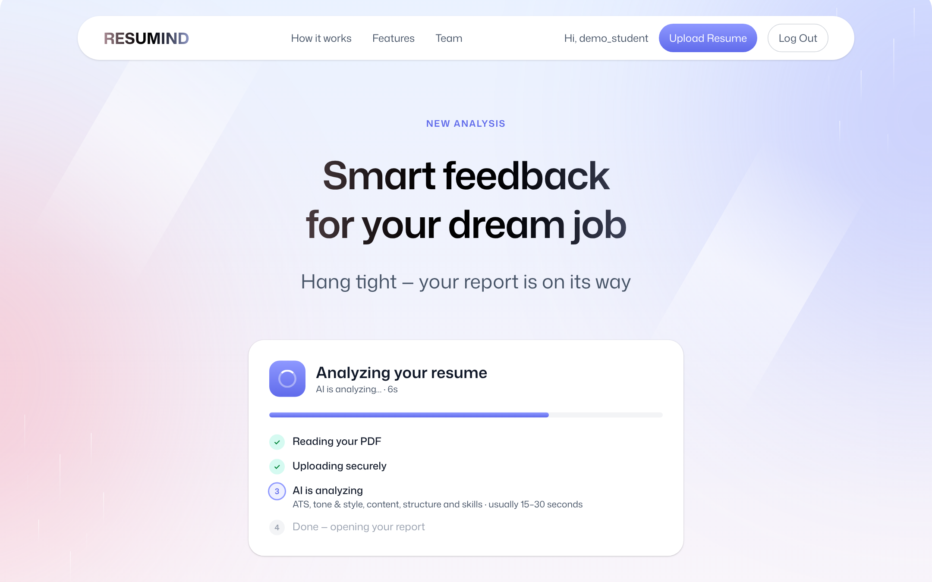
Figure 9: Processing state while Gemini analyses the resume

9.3 Analysis result
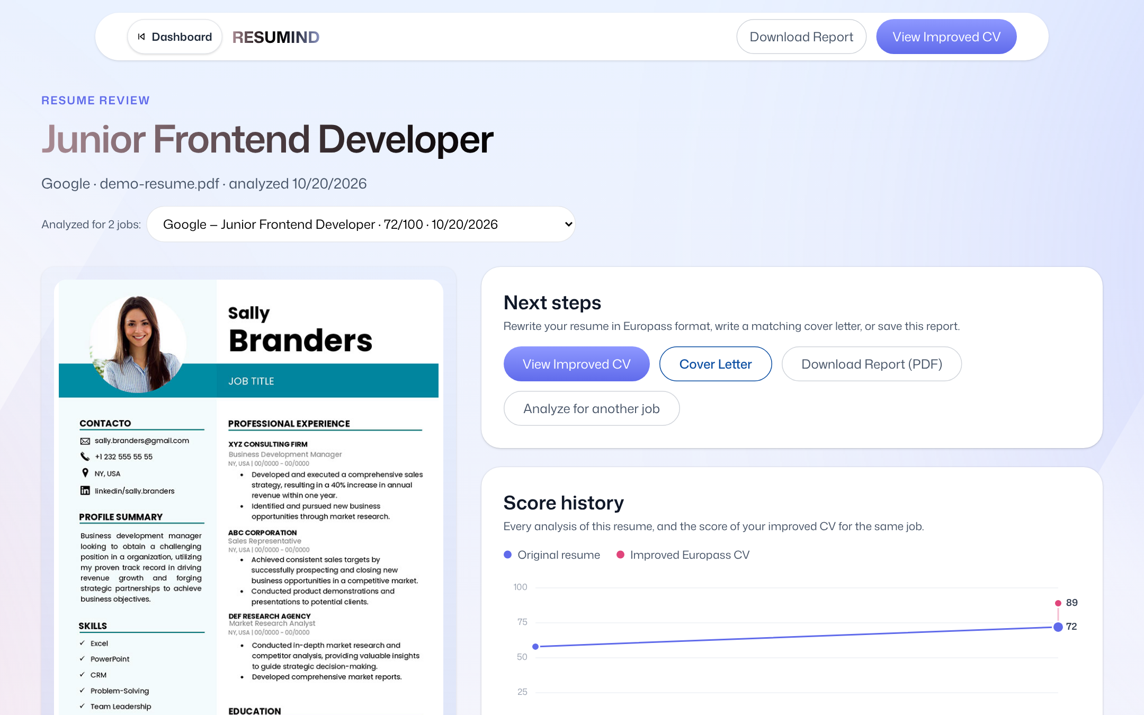
Figure 10: Result page: overall score and category scores
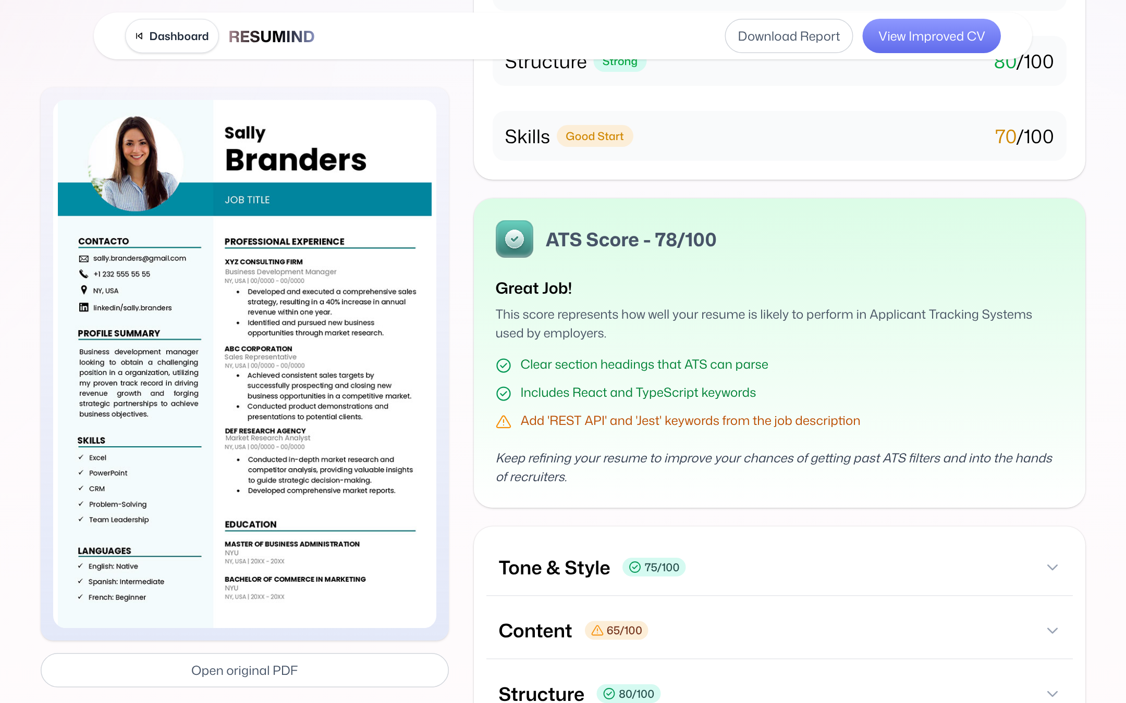
Figure 11: Detailed tips per category

9.4 Europass CV and cover letter
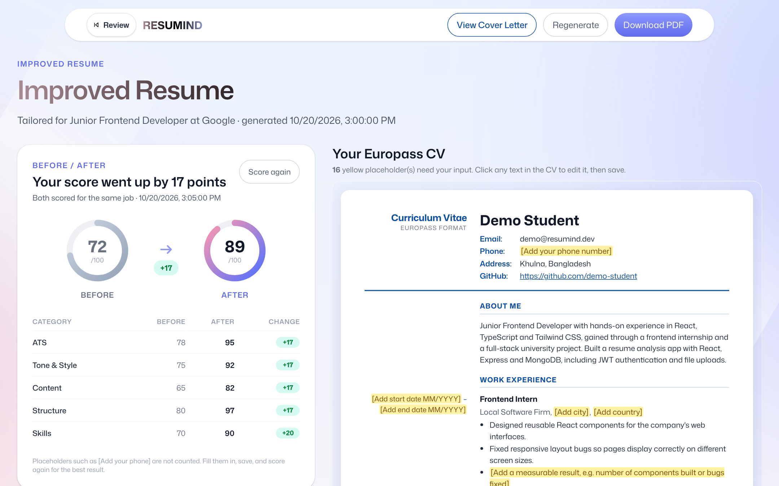
Figure 12: Improved Europass CV with change list
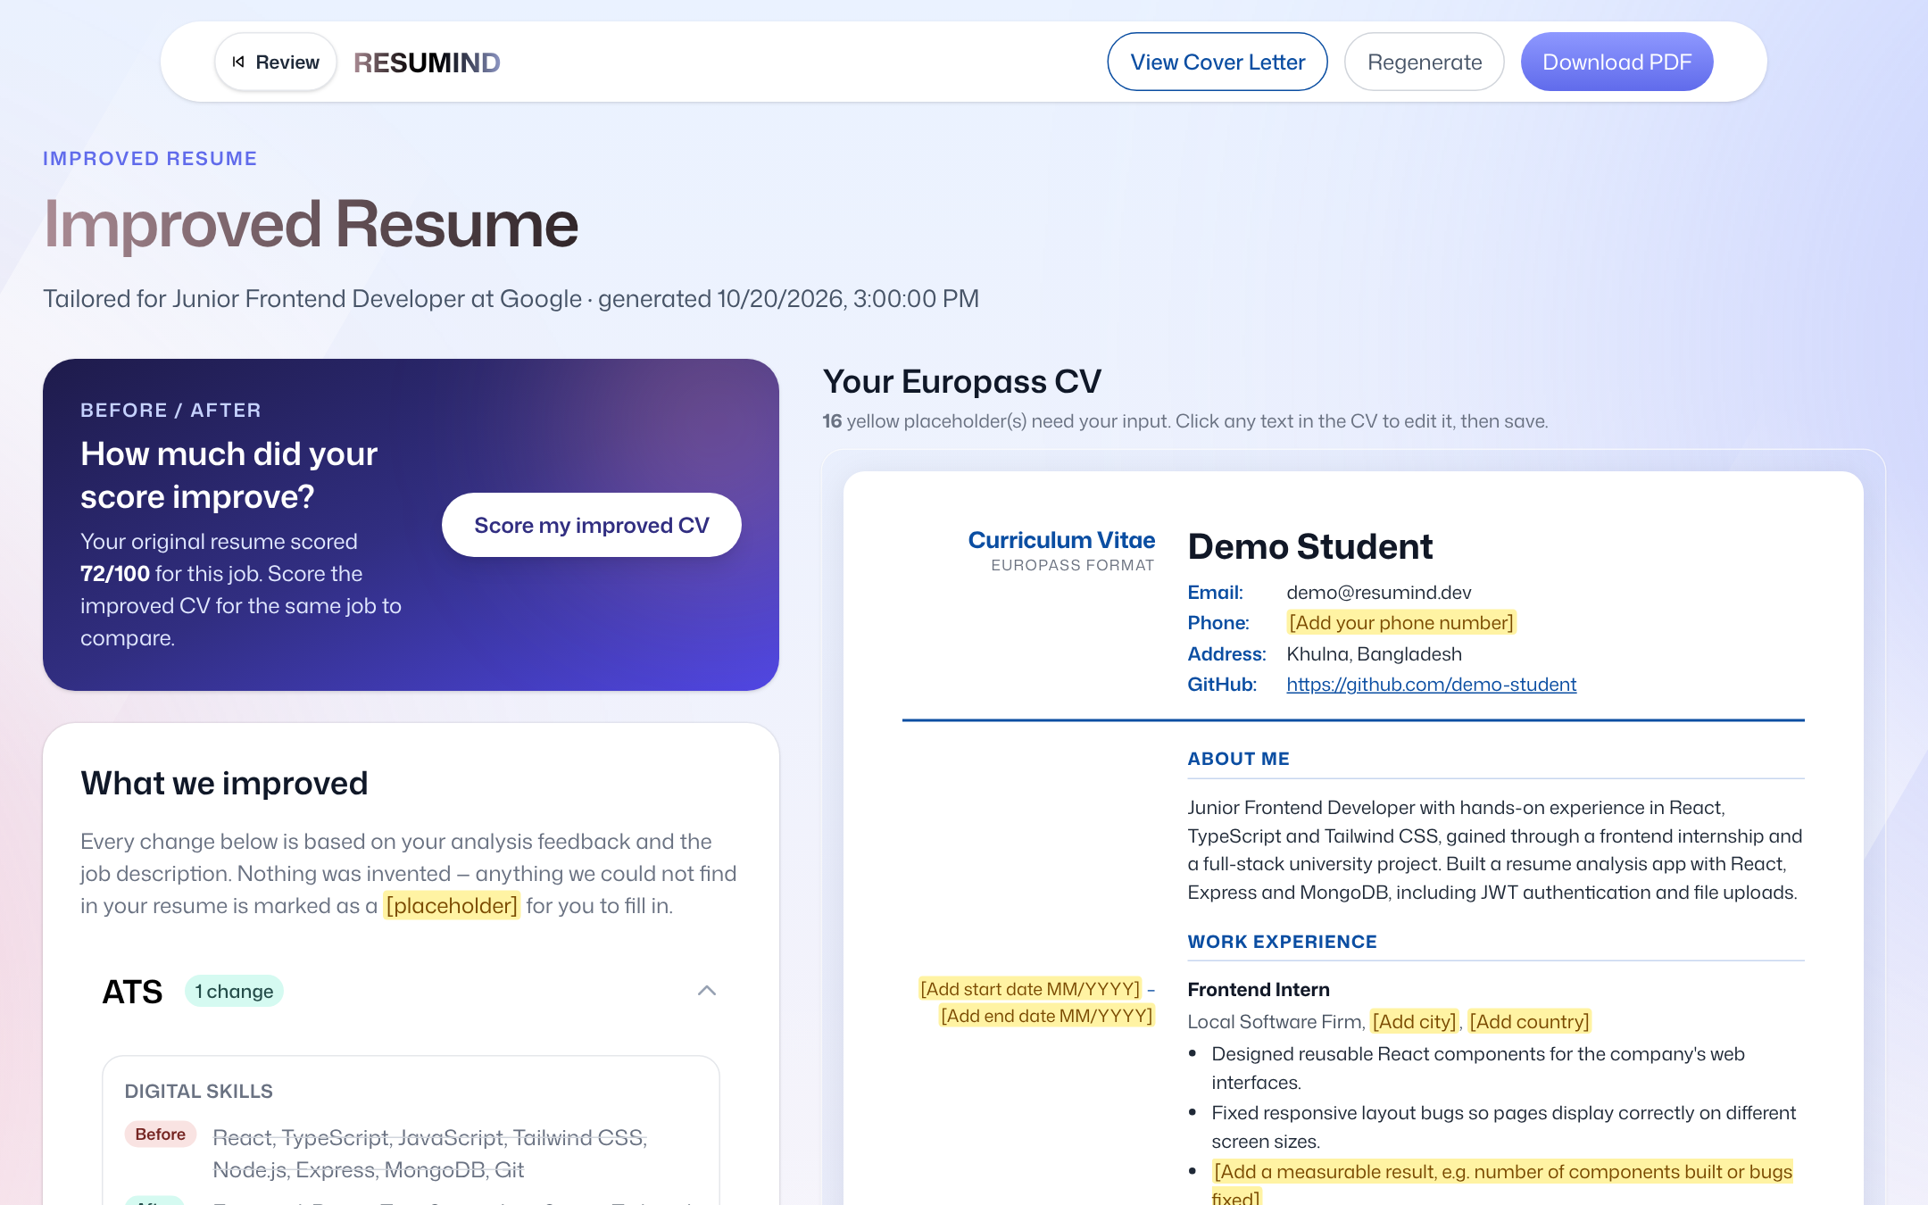
Figure 13: Before / after score comparison
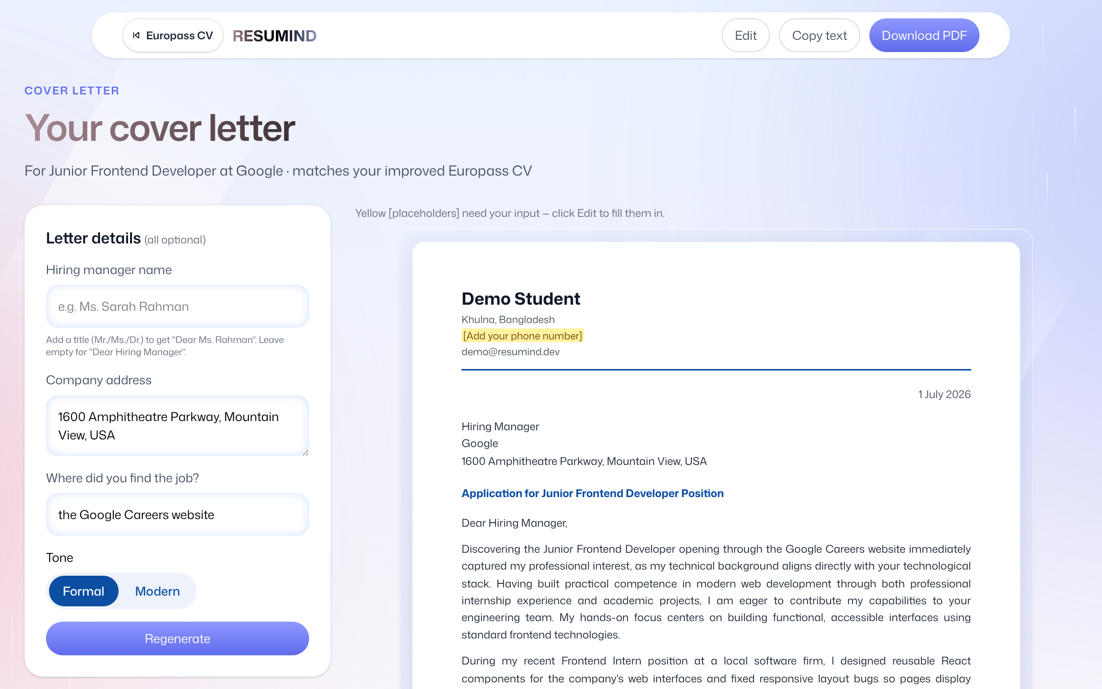
Figure 14: Generated cover letter

9.5 Responsive design
The interface is mobile-first. On phones the result page stacks the feedback above the preview, navigation collapses and all buttons remain within thumb reach; on desktop the layout uses multiple columns.
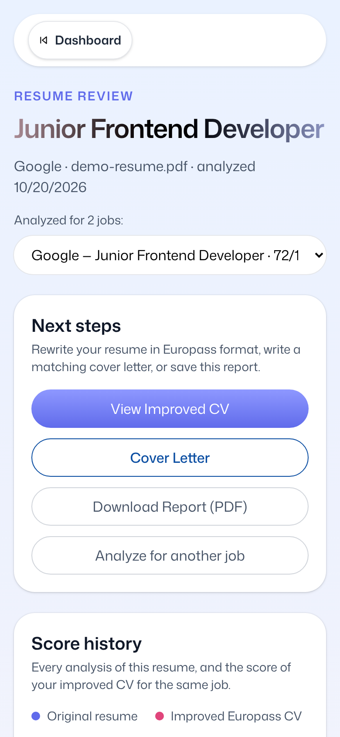
Figure 15: Result page on a phone

10. Testing

10.1 Automated API tests
The backend is tested with Vitest and Supertest, which send real HTTP requests to the Express app. Each test run starts a fresh in-memory MongoDB (mongodb-memory-server) and replaces Gemini with a mock, so the tests are fast, repeatable, need no API key and never touch real data.
Table 9: Automated test suites
Suite | Tests | What is covered
auth.test.js | 10 | Register, login, validation, duplicate e-mail/username, /me, password change (old token rejected), delete account
google.test.js | 9 | Google Sign-In: new and existing users, account linking, unverified e-mail, invalid token, Google-only password rules
resume.test.js | 12 | Upload (PDF only, fake PDF rejected, size), list, get, file/image download, ownership, cascade delete
analyze.test.js | 4 | Analysis with mocked Gemini, input validation, other user's resume, missing API key
europass.test.js | 13 | Improve, post-check rules, edit/reset CV, before/after score, cover letter generate/edit/reset
Total | 48 | All passing in GitHub Actions

10.2 Continuous integration
A GitHub Actions workflow runs on every push and pull request. Job 1 installs the backend with npm ci and runs all 48 tests; job 2 type-checks and builds the frontend. A green tick next to a commit means both jobs passed; Vercel and Render then deploy the same commit.

10.3 Manual and device testing
Table 10: Manual test cases (selection)
ID | Scenario | Expected result | Result
M1 | Sign up, log out, log in again | Dashboard opens; logout returns to the landing page | Pass
M2 | Upload a scanned (image-only) PDF | Clear message: the PDF has no readable text | Pass
M3 | Upload a .docx renamed to .pdf | Rejected: not a real PDF | Pass
M4 | Analyse a CV for a frontend job | Scores and tips shown in about 10–20 s | Pass
M5 | Improve to Europass, edit a line, reload | Edit is kept; reset restores the AI version | Pass
M6 | Score the improved CV | Before/after comparison and chart update | Pass
M7 | Generate a cover letter and download PDF | One A4 page, correct header and salutation | Pass
M8 | Open the app on a phone (360 px) | No horizontal scrolling; all actions reachable | Pass
M9 | Visit an unknown URL | Friendly 404 page with a way back | Pass
M10 | Change password on one device | Other devices are logged out | Pass

11. Results and Discussion
All planned features are implemented, deployed and reachable from a single public URL. In the team's own trials with real student resumes, the analysis typically returned in 10–20 seconds, the Europass rewrite in 20–40 seconds and the cover letter in under 20 seconds on the free Gemini tier.
- Explainable feedback: every score comes with "good" and "improve" tips and an explanation, so users know what to change and why.
- Measured improvement: the before/after score turns the rewrite into a visible result; in the sample data the overall score rose after the Europass rewrite while placeholders kept the CV honest.
- Truthfulness: the post-check prevents invented numbers and dates, and placeholders clearly show the user what to fill in.
- Usability: a single flow from upload to cover letter with a progress stepper; mobile layout tested on real phones.
- Reliability: 48 automated tests and CI on every push; automatic retries reduce failures when Gemini is busy.
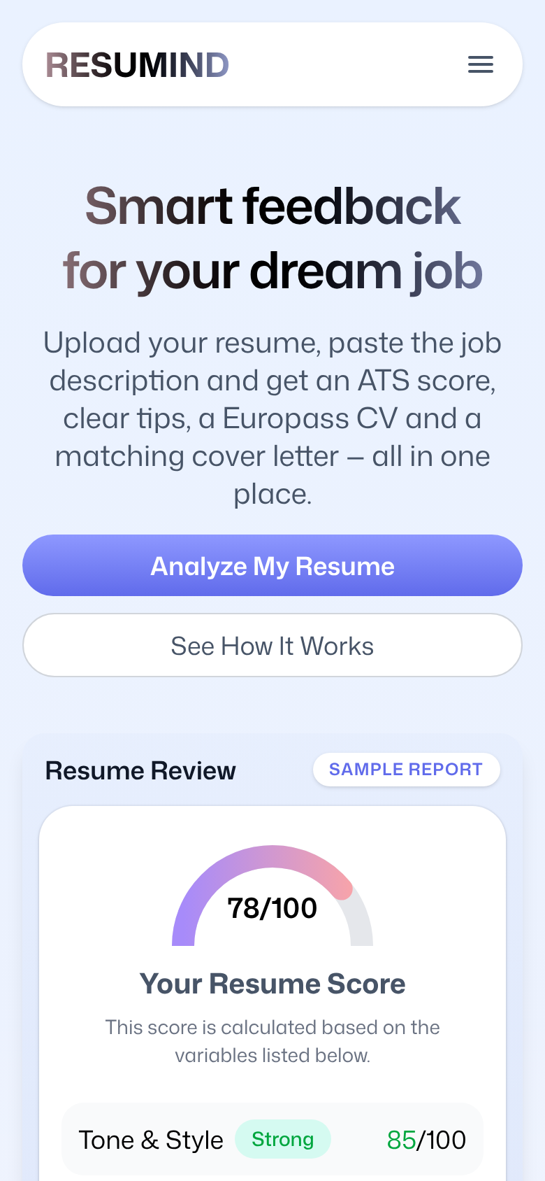
Figure 16: Landing page on a phone

12. Deployment
Table 11: Production environment
Part | Platform | Details
Frontend | Vercel | https://ai-resume-analyzer-psi-lime.vercel.app  Static SPA build of React Router; VITE_API_URL and VITE_GOOGLE_CLIENT_ID set in the dashboard
Backend | Render (free web service) | https://resumind-api-3kpd.onrender.com  Blueprint render.yaml, npm ci --omit=dev, health check /api/health, auto-deploy on push
Database | MongoDB Atlas (M0) | Collections + GridFS; network access 0.0.0.0/0 because Render has no fixed IP
Secrets | .env / dashboards | MONGO_URI, JWT_SECRET (generated by Render), GEMINI_API_KEY, GOOGLE_CLIENT_ID, CLIENT_URL — never committed

Operational note: The free Render instance sleeps after 15 minutes without traffic, so the first request afterwards can take about 50 seconds. Before a demonstration the team opens /api/health once to wake the server.

13. Limitations and Future Work

13.1 Current limitations
- Only text-based PDF resumes are supported; scanned images need OCR.
- AI scores can vary slightly between runs because they come from a language model.
- The free Gemini and Render tiers limit throughput and cause a cold start after inactivity.
- The interface and AI output are in English only.

13.2 Future work
- OCR (e.g. Tesseract) for scanned resumes and support for DOCX uploads.
- Job search integration: paste a LinkedIn or BDJobs link instead of the description.
- Interview preparation: AI-generated questions based on the CV and the job.
- Bangla language support for the interface and feedback.
- Native mobile app (React Native) sharing the same REST API, with push notifications.
- Export the Europass CV as the official Europass XML so it can be imported into the EU portal.
- Recruiter mode: rank several resumes against one job description.

14. Conclusion
RESUMIND shows how a carefully constrained large language model can turn a stressful, opaque step of job hunting into a guided, explainable process. Starting from a tutorial prototype, the team built a complete three-tier system with its own secure backend, a database that follows the course ERD, four AI features with structured output and code-level safeguards, automated testing with continuous integration, and a public deployment that works on phones and desktops. The project met all objectives of the proposal and gave every team member practical experience with full-stack development, AI integration, security and teamwork.

15. Team Contributions
Table 12: Roles and responsibilities
Member | ID | Role | Main responsibilities
Mahammad Hasan | 11220320828 | Team Leader · Frontend Developer + UI/UX Designer | Team coordination; React Router 8 app structure, Zustand auth store, API client and protected routes; all pages (auth, upload, dashboard, result, Europass CV editor, cover letter, account, wipe); responsive Tailwind CSS 4 UI/UX
Shanawaz Sakib | 11220320916 | Core System Integration Engineer | Google Gemini integration: JSON-mode prompts and schemas for analysis, Europass rewrite and cover letter, retries; end-to-end flow PDF → text → Gemini → saved feedback → UI; AI rate limit; Docker Compose setup
Ashikur Rahman Himel | 11220320833 | Database Storage & Quality Controller | MongoDB Atlas schema and Mongoose models (ERD, schema docs, seed data); file storage and input validation; automated API tests (Vitest + Supertest); dependency security audit
Rasel Ratul | 11220320827 | Backend Developer | Express 5 REST API: JWT authentication, Multer upload, controllers, routes, error handling; bcrypt, helmet, CORS, login rate limiting, ownership and PDF magic-byte checks; change-password and delete-account endpoints; Dockerfile

References
- Europass — European Union, "Create your Europass CV", https://europass.europa.eu
- Council of Europe, "Common European Framework of Reference for Languages (CEFR)".
- European Commission, "The European Qualifications Framework (EQF)".
- Google, "Gemini API — Structured output", https://ai.google.dev
- MongoDB, "GridFS" documentation, https://www.mongodb.com/docs
- OWASP Foundation, "Authentication Cheat Sheet" and "Password Storage Cheat Sheet".
- React Router documentation, https://reactrouter.com
- Express.js documentation, https://expressjs.com
- JavaScript Mastery, "Build an AI Resume Analyzer" (YouTube tutorial used for the first prototype).
- Mobile Computing Lab Student Handbook, CSE4204, NUBTK.

